Development of a Real-Time IoE Stream Analytics and Anomaly Detection System using Node-RED and MQTT
Objective:
To develop a real-time IoE stream analytics system that monitors temperature, vibration and current readings, applies threshold-based rules to detect anomalies, and raises ALERT events, following the flow of an MQTT and Node-RED style pipeline.
Procedure:
- Generate a simulated telemetry stream of 600 samples at 5-second intervals starting 21 Oct 2026, 10:00: temperature (mean 27 C, SD 2.0), vibration (mean 3.0 mm/s, SD 0.45) and current (mean 5.0 A, SD 0.7).
- Inject 12 artificial faults: temperature +12 C at four samples, vibration +3.5 mm/s at four samples and current +4.0 A at four samples.
- Apply threshold rules to every sample (the rule stage of a Node-RED flow): temperature above 35 C, vibration above 4.5 mm/s, or current above 7.0 A. A sample is marked ALERT if any rule is exceeded and NORMAL otherwise.
- Count normal and anomalous samples, compute the anomaly rate and list the detected events.
- Plot the temperature, vibration and current streams with their threshold lines and a normal-vs-anomaly summary, and export the results to IoE_Stream_Results.csv.
Program:
import numpy as np
import pandas as pd
import matplotlib.pyplot as plt
from datetime import datetime, timedelta

np.random.seed(23)

# 1. Generate simulated IoE telemetry stream
N = 600
start = datetime(2026, 10, 21, 10, 0)

timestamps = [
start + timedelta(seconds=5*i) for i in range(N)
]

temperature = np.random.normal(27, 2.0, N)
vibration = np.random.normal(3.0, 0.45, N)
current = np.random.normal(5.0, 0.7, N)

# 2. Inject artificial anomalies
temperature[[75, 76, 77, 180]] += 12
vibration[[181, 182, 310, 311]] += 3.5
current[[450, 451, 452, 530]] += 4.0

df = pd.DataFrame({
"timestamp": timestamps,
"temperature_C": temperature.round(2),
"vibration_mm_s": vibration.round(2),
"current_A": current.round(2)
})

# 3. Threshold-based anomaly detection
df["temp_anomaly"] = df["temperature_C"] > 35
df["vibration_anomaly"] = df["vibration_mm_s"] > 4.5
df["current_anomaly"] = df["current_A"] > 7.0

df["anomaly"] = df[
["temp_anomaly", "vibration_anomaly", "current_anomaly"]
].any(axis=1)

df["status"] = np.where(df["anomaly"], "ALERT", "NORMAL")

anomalies = int(df["anomaly"].sum())
normal = N - anomalies

print("=" * 55)
print("IoE STREAM ANALYTICS AND ANOMALY DETECTION")
print("=" * 55)
print("Total samples:", N)
print("Normal samples:", normal)
print("Anomalous samples:", anomalies)
print(f"Anomaly rate: {anomalies/N*100:.2f}%")

print("\nThresholds:")
print("Temperature > 35 °C")
print("Vibration > 4.5 mm/s")
print("Current > 7.0 A")

print("\nSample detected events:")
print(df[df["anomaly"]][
["timestamp", "temperature_C", "vibration_mm_s",
"current_A", "status"]
].head(10).to_string(index=False))

# 4. Plot stream analytics dashboard
fig, ax = plt.subplots(2, 2, figsize=(14, 9))

ax[0, 0].plot(df["timestamp"], df["temperature_C"])
ax[0, 0].axhline(35, linestyle="--", label="Threshold")
ax[0, 0].set_title("Temperature Stream")
ax[0, 0].set_ylabel("Temperature (°C)")
ax[0, 0].tick_params(axis="x", rotation=25)
ax[0, 0].legend()
ax[0, 0].grid(True, alpha=0.3)

ax[0, 1].plot(df["timestamp"], df["vibration_mm_s"])
ax[0, 1].axhline(4.5, linestyle="--", label="Threshold")
ax[0, 1].set_title("Vibration Stream")
ax[0, 1].set_ylabel("Vibration (mm/s)")
ax[0, 1].tick_params(axis="x", rotation=25)
ax[0, 1].legend()
ax[0, 1].grid(True, alpha=0.3)

ax[1, 0].plot(df["timestamp"], df["current_A"])
ax[1, 0].axhline(7.0, linestyle="--", label="Threshold")
ax[1, 0].set_title("Current Stream")
ax[1, 0].set_ylabel("Current (A)")
ax[1, 0].tick_params(axis="x", rotation=25)
ax[1, 0].legend()
ax[1, 0].grid(True, alpha=0.3)

ax[1, 1].bar(
["Normal", "Anomaly"],
[normal, anomalies]
)
ax[1, 1].set_title("Anomaly Detection Summary")
ax[1, 1].set_ylabel("Number of Samples")
ax[1, 1].grid(axis="y", alpha=0.3)

plt.tight_layout()
plt.savefig("IoE_Anomaly_Detection.png", dpi=180)
plt.show()

# 5. Export results for further analysis
df.to_csv("IoE_Stream_Results.csv", index=False)

print("\nSimulation completed successfully.")
print("Dashboard image: IoE_Anomaly_Detection.png")
print("Dataset: IoE_Stream_Results.csv")

# Download files when running in Google Colab
from google.colab import files
files.download("IoE_Anomaly_Detection.png")
files.download("IoE_Stream_Results.csv")

Output:
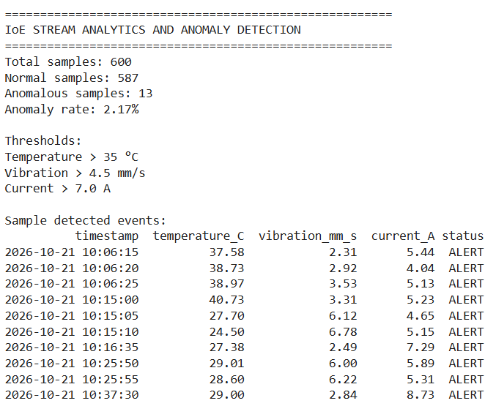
Fig. 1: Console output (summary, thresholds and detected events)
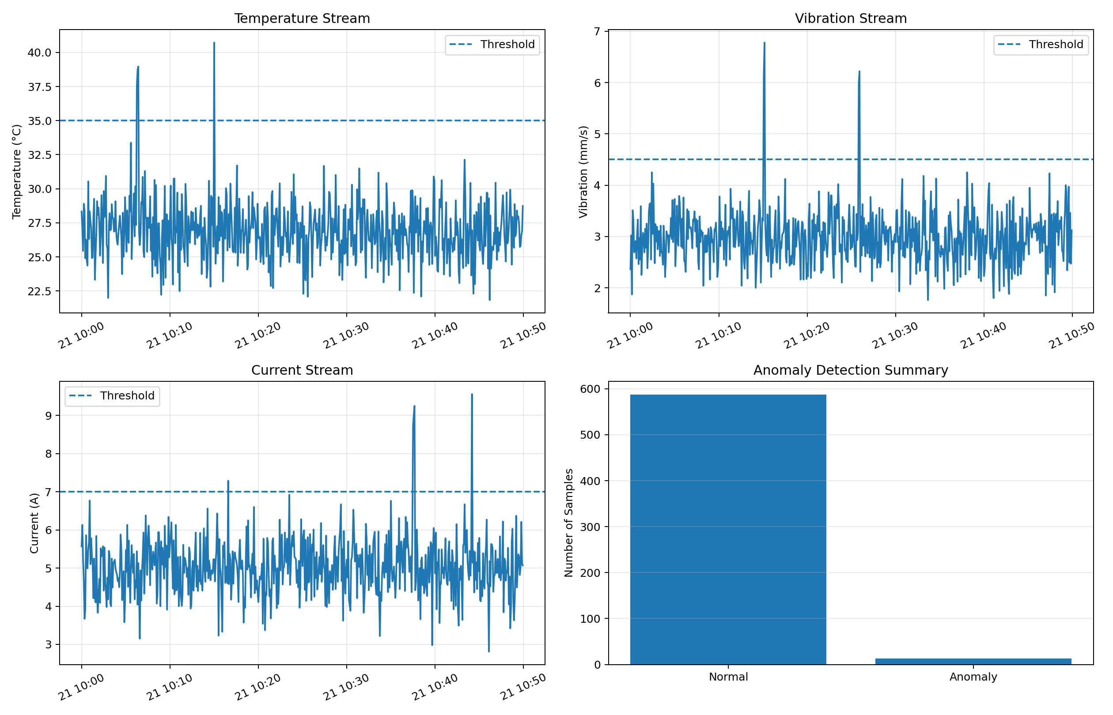
Fig. 2: Stream analytics dashboard (temperature, vibration, current and anomaly summary)
Simulation in Node-RED:
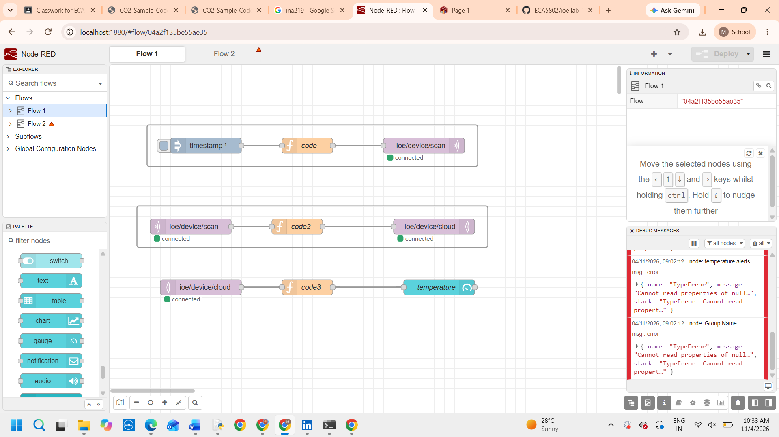
Dashboard output:
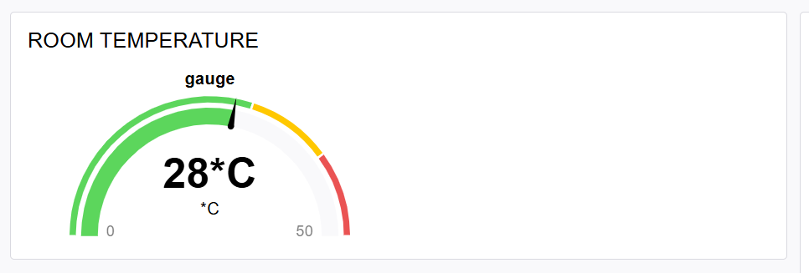
Results:
Metric | Value
Total samples | 600
Normal samples | 587
Anomalous samples (ALERT) | 13
Anomaly rate | 2.17%

Signal | Threshold | Samples above threshold | Peak value
Temperature | > 35 °C | 4 | 40.73 °C
Vibration | > 4.5 mm/s | 4 | 6.78 mm/s
Current | > 7.0 A | 5 | 9.56 A

13 of the 600 samples (2.17%) were flagged. All 12 injected faults were detected: 4 temperature, 4 vibration and 4 current spikes, plus one extra current alert at 10:16:35 (7.29 A) that came from normal random variation just above the 7.0 A threshold, which is a false alarm of a fixed-threshold rule. The alerts are clustered at 10:06, 10:15, 10:25, 10:37 and 10:44, and each is visible as a spike above the dashed threshold line in the graphs.
Result:
The system classified the stream into 587 normal and 13 anomalous samples (2.17% anomaly rate) and flagged every injected fault in real time using simple threshold rules on temperature, vibration and current. Threshold detection is fast and easy to run in a Node-RED flow, although a fixed limit can raise an occasional false alarm, as the single extra current alert shows. All data are simulated, not measured from real equipment.

